**ATMISOService Installation Document**

1. Copy the service folder(ATMISOService) to desired location
2. Run Install.bat as Administrator to Install the service.
3. Make sure Udl/ATMISOService.udl exists. This is used for connection to CBS database.
4. Configure CBS Database on **ATMISOService.udl**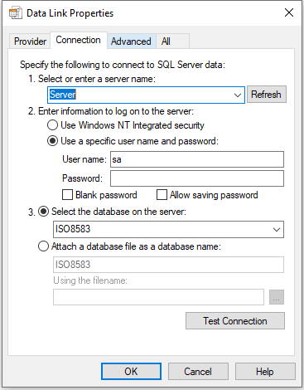
5. Edit ATMISOService.exe config file by opening it on Notepad. 
6. Edit the values,
   1. ServiceIP: If the server has multiple IP, use the desired Connection IP, leave it blank if there is only one IP on the server.
   2. ServicePort: Enter the desired service port for communication 
7. Open windows services (services.msc).Find ATMISOService on the list and start the service to activate it.